Documentation for Changes to the Reward function and Average Demand
The steps here will outline the proposed changes to be made for the reward function and to implement the EWMA. Full Analysis can be found under “Kavish” GitHub branch under file “Research on Obs Space and Reward Function”.

Moving from Simple Moving Average (SMA) to Exponential Weighted Moving Avergage (EWMA).
EMA (Exponential Moving Average): This has "Recency Bias." The most recent data point gets the most weight, and the importance of older data fades away exponentially.
EMA does not need a buffer. It only needs one number: the previous EMA value.
- ${EMA}_{NEW}=\left(α×Current\right)+((1-α)×{EMA}_{OLD})$
- $α$ is the "Smoothing Factor" -> If $α$ = 0.3, it means: "Take 30% of the new reality and keep 70% of history." You only add 1 new input per sensor, regardless of how long the history is.

Python Implementation
In your Python script, find where you define your parameters using parameter_generator. Below this add the following two lines:
params['demand_moving_average'] = False # Turn off SMA
params['demand_exp_moving_average'] = True # Turn on EMA
It should look something like this:
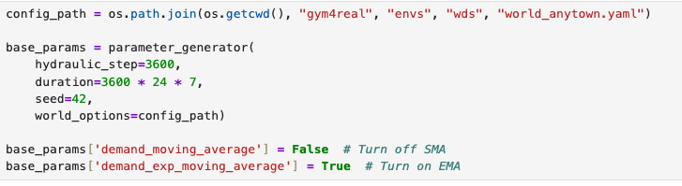

Reward Function
We would like to add two factors into our reward function which currently are not being considered:
Objective | Function | Weight | Reasoning
Efficiency | check_pumps_flow | -0.10 (w₃) | Saves money. Encourages using gravity instead of pumps when possible.
Longevity | check_pumps_updates | -0.05 (w₄) | Saves hardware. Prevents rapid oscillation (flickering).

Python Implementation
Please replace eny.py and rewards.py which can be found in the folder ./gym4real/envs/wds with the env.py and rewards.py files in my branch which can be found under Kavish/Updated-Files.
I would recommend you keep the old files to be safe and change their name to original.

